# Brainstorm

**TIP**

You can select a sticky note and hit the pencil [switch to sketch] icon to start drawing!

### Before you collaborate

##### A little bit of preparation goes a long way with this session. Here’s what you need to do to get going.

###### 10 minutes

**1**

### Define your problem statement

##### What problem are you trying to solve? Frame your problem as a How Might We statement. This will be the focus of your brainstorm.

###### 5 minutes

**2**

### Brainstorm

##### Write down any ideas that come to mind that address your problem statement.

###### 10 minutes

**3**

### Group ideas

##### Take turns sharing your ideas while clustering similar or related notes as you go. Once all sticky notes have been grouped, give each cluster a sentence-like label. If a cluster is bigger than six sticky notes, try and see if you and break it up into smaller sub-groups.

###### 20 minutes

**4**

### Prioritize

##### Your team should all be on the same page about what's important moving forward. Place your ideas on this grid to determine which ideas are important and which are feasible.

**20 minutes**

### After you collaborate

You can export the mural as an image or pdf to share with members of your company who might find it helpful.

**Quick add-ons**

# & idea prioritization

**PROBLEM**

**How might we [your problem statement]?**

Use this template in your own brainstorming sessions so your team can unleash their imagination and start shaping concepts even if you're not sitting in the same room.

1. Team gathering

Define who should participate in the session and send an invite. Share relevant information or pre-work ahead.

1. Set the goal

Think about the problem you'll be focusing on solving in the brainstorming session.

1. Learn how to use the facilitation tools

Use the Facilitation Superpowers to run a happy and productive session.

**PREETHI**

T

u

ealth w

w

applications help lose calorie and without harming health. In other they mainly focus ealthy eating

lifestyle, degree of

In this app, the user bets a certain amount of money that he’ll achieve a certain weight goal in a certain amount of time

Betting apps are the answer to this question

Need to define the set of features that you want to integrate into your diet and nutrition applications

The app measures the number of calories absorbed and burnt and then suggests them with dietary recommendations from the comprehensive food database

affordable support

All of these can enable users to fill in the healthy meal habits that let them create the best diet plan

**TIP**

Add customizable tags to sticky notes to make it easier to find, browse, organize, and categorize important ideas as themes within your mural.

The exact make-up of a diversified, balanced and healthy diet will vary depending on the individual needs

They let users record meals and daily intake of water, monitor calories burned and consumed, select a fitness program as per health conditions, and monitor its implementation to get healthy food.

Cost Effectively

To make user friendly

Reduce the storage capacity

To provide a valid result

platform independent

## 

**The app measures the number of calories absorbed and burnt and then suggests them with dietary recommendations from the comprehensive food database**

Users must fill data such as desired weight, diet, and food preferences

**NETHRASREE**

## 

Nutrition and Physiotherapy

**Nutrition can directly affect recovery and function while an individual is under a physical therapist's care**

They also track the progress of pregnant women and keep them health

The app then creates a diet chart for a day, week, or a month according to the data filled

Money is by far the biggest motivation for weight loss

**NITHYASHREE**

## 

good nurition

People are consuming more foods high in energy, fats, free sugars or salt/ sodium

The increased production of processed food, rapid urbanization and changing lifestyles have led to a shift in dietary patterns.

(e.g. age, gender,

physical activity),

**RAJASURUDHI**

## 

Need to define the group of your customers for whom you want to cater

Think about the answers to these questions to get better clarity of your target audience

Getting a clear idea of your target audience helps you plan your app’s design, structure, and strategy of marketing

1. Share the mural

**Share a view link** to the mural with stakeholders to keep them in the loop about the outcomes of the session.

1. Export the mural

Export a copy of the mural as a PNG or PDF to attach to emails, include in slides, or save in your drive.

Target

M

m

Think about the answers to these questions to get better clarity of your target

**10 minutes** to prepare

**1 hour** to collaborate

**2-8 people** recommended

[**Open article**](https://support.mural.co/en/articles/2113740-facilitation-superpowers)

Cost

cultural context, locally

All of these can enable users to fill in the healthy meal habits that let them create the best diet plan

They also track the progress of pregnant women and keep them healthy

These types of special diet apps target a certain audience and are highly effective

These applications help users lose calorie and weights without harming their health. In other words, they mainly focus on healthy eating

**Key rules of brainstorming**

To run an smooth and productive session

If they lose that much body weight, then they get their money back otherwise, they will lose the money

dietary customs

available foods and

They also track the progress of pregnant women and keep them healthy

#### Keep moving forward

Strategy blueprint

Define the components of a new idea or strategy.

[Open the template](https://app.mural.co/template/e95f612a-f72a-4772-bc48-545aaa04e0c9/984865a6-0a96-4472-a48d-47639307b3ca)

**Customer experience journey map**

Stay in topic. Defer judgment.

Encourage wild ideas. Listen to others.

#### Importance

If each of these

Understand customer needs, motivations, and obstacles for an experience.

[**Open the template**](https://app.mural.co/template/b7114010-3a67-4d63-a51d-6f2cedc9633f/c1b465ab-57af-4624-8faf-ebb312edc0eb)

Go for volume. If possible, be visual.

tasks could get

done without any difficulty or cost, which would have the most positive impact?

Strengths, weaknesses, opportunities & threats

Identify strengths, weaknesses, opportunities, and threats (SWOT) to develop a plan.

[Open the template](https://app.mural.co/template/6a062671-89ee-4b76-9409-2603d8b098be/ca270343-1d54-4952-9d8c-fbc303ffd0f2)

TIP

Participants can use their cursors to point at where sticky notes should go on the grid. The facilitator can confirm the spot by using the laser pointer holding the **H key** on the keyboard.

[Share template feedback](https://muralco.typeform.com/to/CiqaHVat?typeform-source=app.mural.co)

[**Share template feedback**](https://muralco.typeform.com/to/CiqaHVat?typeform-source=app.mural.co)

#### Feasibility

Regardless of their importance, which tasks are more feasible than others? (Cost, time, effort, complexity, etc.)

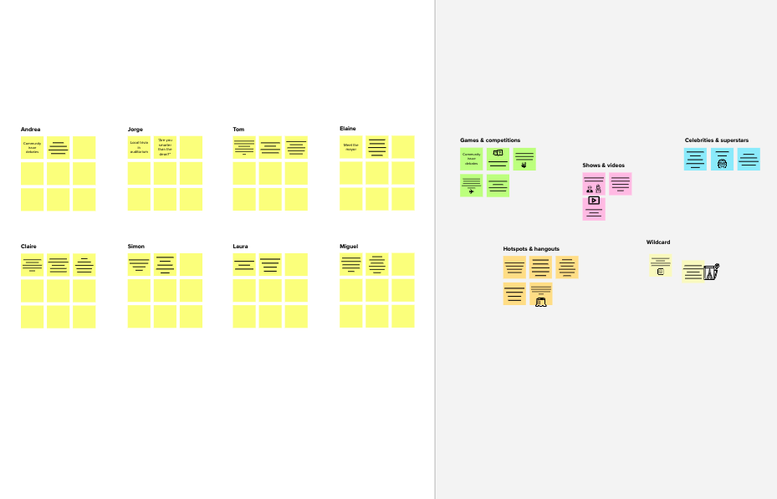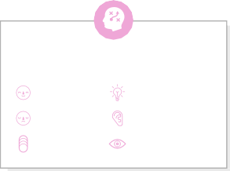

They also track

hese

In this app,

sers

bets a the progress of

H their certain

eights pregnant women

the user

and keep them

ords, healthy

on h amount

If they lose that

of money achieve a then they get their

much body weight,

that he’ll otherwise, they will lose the money

certain money back

weight goal amount of the biggest

oney is by far

in a certain time otivation for

weight loss

**Template**

**Need some inspiration?**

See a finished version of this template to kickstart your work.

[**Open example**](https://app.mural.co/template/e5a93b7b-49f2-48c9-afd7-a635d860eba6/93f1b98d-b2d2-4695-8e85-7e9c0d2fd9b9)